🗺️ Overview



REMEDIATION REPORT
for
MEGAQUAGGA PUBLISHING
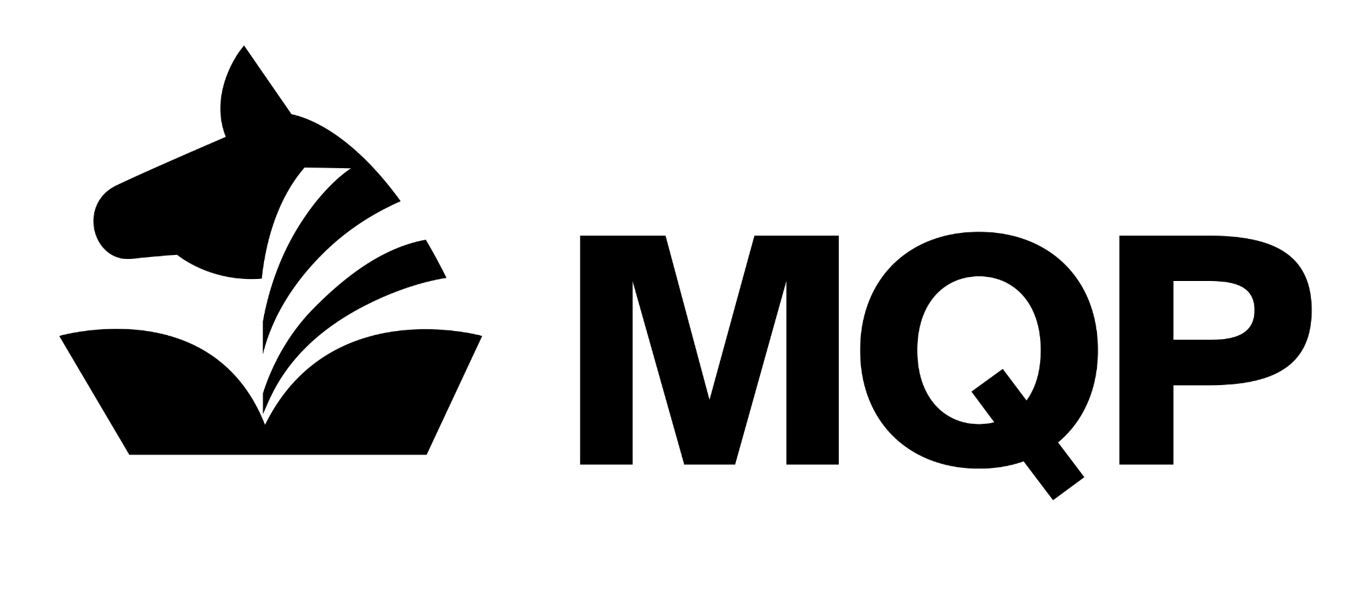
Version 1.0 (12/01/2025)
Prepared by Jerome Schaeffer | Presented to MEGAQUAGGA PUBLISHING

DISCLAIMER: This document contains proprietary and confidential information. 0x2A SECURITY guarantees the confidentiality of the information and any other material that has or will be disclosed during the performance of this service. A mutual non-disclosure agreement of confidential information is assumed between 0x2A SECURITY and MEGAQUAGGA PUBLISHING, limiting the use of confidential information exclusively for purposes associated with properly delivering this service.

EXECUTIVE SUMMARY
During this remediation project, we strengthened the security of the MegaQuagga WordPress environment by adding several layers of protection in front of the existing web server. First, we introduced an Apache reverse proxy to act as a gatekeeper, allowing us to inspect incoming traffic at the application level (Layer 7). This proxy was equipped with ModSecurity and the OWASP Core Rule Set (CRS), providing a Web Application Firewall (WAF) capable of detecting and blocking common web attacks. We also enabled SSL offloading, ensuring that all visitors connect over encrypted HTTPS, improving privacy and preventing attackers from intercepting or tampering with web traffic.

These improvements directly mitigate several security risks present in the original configuration. Previously, the WordPress server was exposed to the internet with no protection beyond a basic Layer 4 firewall, making it vulnerable to attacks such as cross-site scripting (XSS), malicious payload injection, and other application-layer exploits. By routing all traffic through a secure reverse proxy, enabling active WAF protections, and enforcing HTTPS for all external connections, we significantly reduce the risk of web-based attacks and improve the overall confidentiality, integrity, and availability of the site.

🦾 Actions Taken

ACTIONS TAKEN
This section outlines the actions taken on which assets to remediate which vulnerabilities.

Vulnerability | Remediation Solution
WordPress is vulnerable to web application attacks | Implemented a reverse proxy with ModSecurity WAF and the OWASP Core Rule Set (CRS)
Unencrypted web traffic | Implemented SSL offloading and enforced HTTPS using Apache VirtualHost configuration

Remediation Solution #1: Reverse Proxy + ModSecurity WAF

Vulnerability Addressed:
WordPress is vulnerable to web application attacks (e.g., XSS), originally discovered using WPScan during the vulnerability assessment phase.

Step-by-Step Actions Taken
- Identified the XSS vulnerability using WPScan during a structured scan of the WordPress site.
- Confirmed the vulnerability by crafting and testing an XSS payload, verifying that malicious JavaScript executed in the browser.
- Deployed an Apache reverse proxy server on the LAN at 10.20.30.220 to act as a Layer 7 inspection point.
- Modified pfSense NAT rules, changing the Redirect Target IP from 10.20.30.130 (WordPress server) to 10.20.30.220 (reverse proxy) so all HTTP traffic now flows through the proxy.
- Verified the new traffic flow using pfSense packet captures and Wireshark, confirming requests now terminated at the reverse proxy.
- Enabled ModSecurity on the reverse proxy and installed the OWASP Core Rule Set (CRS) to detect common web attacks.
- Operated ModSecurity in detection mode, using Graylog SIEM to monitor alerts triggered by malicious test input.
- Tested the WAF’s effectiveness by re-running the XSS payload and confirming ModSecurity logged and identified the attack.
- Accessed the reverse proxy via SSH from the Blue-Team Workstation and modified the ModSecurity configuration using nano.
- Switched ModSecurity to prevention mode, enabling active blocking of malicious requests.
- Restarted Apache to apply changes.
- Tested again with the original exploit and verified the XSS payload was now fully blocked while legitimate site traffic loaded normally.

Remediation Solution #2: SSL Offloading + Enforced HTTPS

Vulnerability Addressed:
Unencrypted web traffic traveling over HTTP, making user data susceptible to interception.

Step-by-Step Actions Taken
- Planned SSL offloading so the reverse proxy handles encryption while the backend WordPress server continues using HTTP internally.
- Edited the Apache HTTP configuration on the reverse proxy and added rewrite rules to automatically redirect all http:// traffic to https://.
- Created a new HTTPS VirtualHost configuration file using:
touch /etc/apache2/sites-available/000-default-ssl.conf
- Opened the file in nano and added the complete <VirtualHost _default_:443> configuration, including:
  - Enabling SSL (SSLEngine On)
  - Adding certificate and key paths
  - Setting X-Forwarded-* and reverse proxy settings
  - Proxying requests to the backend server at 10.20.30.130
- Saved and enabled the new VirtualHost on Apache.
- Restarted Apache to apply the HTTPS configuration.
- Updated pfSense NAT and firewall rules to add a new Port Forward and allow-list entry for port 443 to 10.20.30.220.
- Tested HTTPS access from an external client, confirming that:
  - HTTP requests were redirected to HTTPS
  - The site loaded securely on port 443
  - Internal proxy-to-server communication remained on HTTP as intended.

☑️ Evidence of Remediation

EVIDENCE OF REMEDIATION
This section documents evidence of the remediations being implemented. This evidence may take the form of details from packet captures (for example, alterations in traffic flow or packet headers), ModSecurity logs appearing in the Graylog SIEM, or output from command-line tools. For each remediation, we provide evidence of the original state as well as the current altered state.

Reverse proxy
These are alterations to MegaQuagga’s environment associated with implementing the reverse proxy server responsible for implementing our two remediations (WAF & SSL offloading).

Item | Original Vulnerable State | Current Remediated State
Traffic Flow (PCAP Evidence) | Traffic from WAN went directly to WordPress server at 10.20.30.130. PCAP: pfSense-WAN-1.pcap — packets #19, #47 show direct request/response path. | Traffic now routes through reverse proxy 10.20.30.220 before reaching backend server. PCAP: pfSense-LAN-2.pcap — packets #4, #16 show request → proxy → backend sequence.
Apache Configuration Change | /etc/apache2/sites-available/000-default.conf had no reverse proxy settings. | Reverse proxy directives added: ProxyPass / http://10.20.30.130/ and ProxyPassReverse / http://10.20.30.130/.

Web Application Firewall (WAF)
These are alterations to MegaQuagga’s environment associated with implementing the WAF remediation.

Item | Original Vulnerable State | Current Remediated State
ModSecurity Engine Setting | /etc/modsecurity/modsecurity.conf contained SecRuleEngine DetectionOnly, meaning ModSecurity was not blocking attacks. | ModSecurity updated to active blocking mode using SecRuleEngine On.
PCAP Traffic (Blocked Attack Evidence) | pfSense-LAN-2.pcap shows XSS payload successfully reaching backend server (packets #4, #12, #38). | pfSense-LAN-3.pcap shows the WAF blocking the payload. Packets #33–36 show “Nothing generated as request was blocked” followed by an HTTP/1.1 403 Forbidden response.
Graylog Alerts | No alerts existed, and no Layer 7 attack detection was occurring. | ModSecurity CRS alerts appeared in Graylog during testing (observed live, though not saved).

SSL Offloading
These are alterations to MegaQuagga’s environment associated with implementing the WAF remediation.

Item | Original Vulnerable State | Current Remediated State
Apache HTTP Config Redirect | No HTTP to HTTPS redirection existed in /etc/apache2/sites-available/000-default.conf. | Added HTTPS redirection rules: RewriteEngine On and RewriteRule ^/(.*) https://%{HTTP_HOST}/$1 [R=301,L].
HTTPS VirtualHost File | No SSL VirtualHost configuration file existed. | New file created: /etc/apache2/sites-available/000-default-ssl.conf containing the <VirtualHost _default_:443> block and SSL settings.
Certificate & Key Files | No SSL certificates were deployed on the reverse proxy. | Certificate and key deployed: /etc/ssl/certs/megaquagga.local.cert and /etc/ssl/private/megaquagga.local.key.
pfSense NAT & Firewall Rules | Only port 80 was forwarded to WordPress server; no HTTPS rule was present. | New pfSense NAT and firewall rules added to forward WAN port 443 traffic to 10.20.30.220 (reverse proxy).
PCAP Evidence (HTTPS Traffic) | pfSense-LAN-2.pcap shows HTTP-only traffic. | pfSense-LAN-4.pcap captures HTTPS traffic flowing through port 443 to the reverse proxy.

🩺 Recommendations

RECOMMENDATIONS
This section outlines recommendations for continued monitoring and next steps for future remediations to further strengthen MegaQuagga’s security posture.

Recommendation #1: Regularly Review WAF Alerts and Tune ModSecurity Rules
Now that ModSecurity is actively blocking attacks, it’s important to review WAF alerts on a routine basis using Graylog or local logs. This helps identify false positives, emerging attack patterns, and any rules that may need adjustment. Rule tuning is a normal ongoing task for maintaining a WAF, and ensures that legitimate users aren’t accidentally blocked while attackers continue to be stopped effectively.

Recommendation #2: Keep WordPress and Its Plugins Fully Updated
The original vulnerability was discovered through WPScan, which means it was caused by outdated or vulnerable WordPress components. To prevent similar weaknesses in the future, the WordPress core, themes, and plugins should be updated regularly. Scheduling monthly maintenance windows and enabling automatic updates where possible will reduce exposure to newly discovered vulnerabilities.

Recommendation #3: Implement Periodic Vulnerability Scanning and Security Testing
To maintain a strong security posture, schedule recurring vulnerability scans (using tools like WPScan, OpenVAS, or other approved scanners). This ensures new issues are identified quickly as software changes over time. Additionally, performing simple periodic penetration tests on the WordPress site helps confirm that the reverse proxy, WAF, and SSL configuration continue functioning as intended.

📍 Conclusion

CONCLUSION
During this project, we implemented a reverse proxy, activated a Web Application Firewall, and enabled SSL offloading to strengthen the security of the MegaQuagga WordPress environment. These remediations addressed the previously discovered vulnerabilities, including web application attack exposure and unencrypted traffic reaching the server. Moving forward, regular WAF alert reviews, consistent WordPress updates, and periodic vulnerability scanning are recommended to maintain and improve the site’s security posture.

